**5.4. INTERFACE DESIGN**

This section will show the interface hierarchy, interface design and how the user use the application and interact with it.

**5.4.1. Interface Hierarchy**

|  |
| --- |
|  |

Figure 5.1: Interface Hierarchy

**5.4.2. User Function Interfaces**

**1-Login Page**

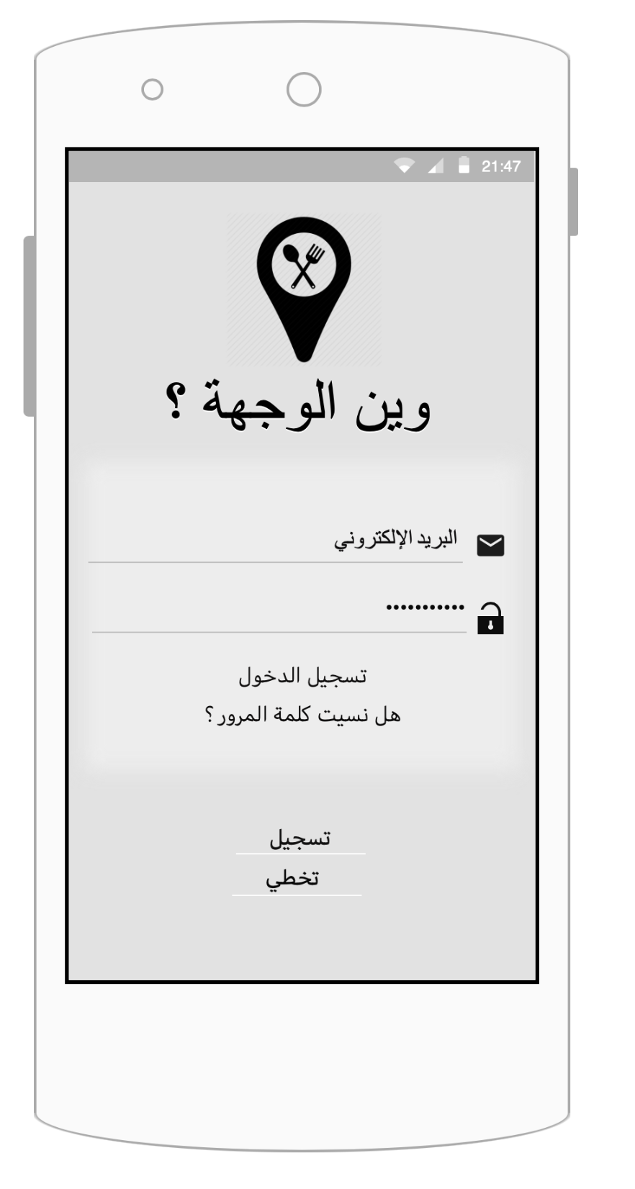

1

2

3

4

5

6

Figure 5.2: Login page.

|  |  |
| --- | --- |
| Function Number | Function Description |
| 1 | This is an input field for the user’s email. |
| 2 | This is an input field for the user’s password. |
| 3 | This button checks the input fields and then directs the user to the home page.  If some fields are empty or the inputs are not valid, error message will be displayed (as shown in Figures 5.12, and 5.17), and the user stays in the same page. |
| 4 | This button is for when the user forgets the password. |
| 5 | The register buttons. |
| 6 | This skip button is for when the user doesn’t want to login or register. |

Table 5.1: Login page.

**2-Register Page**

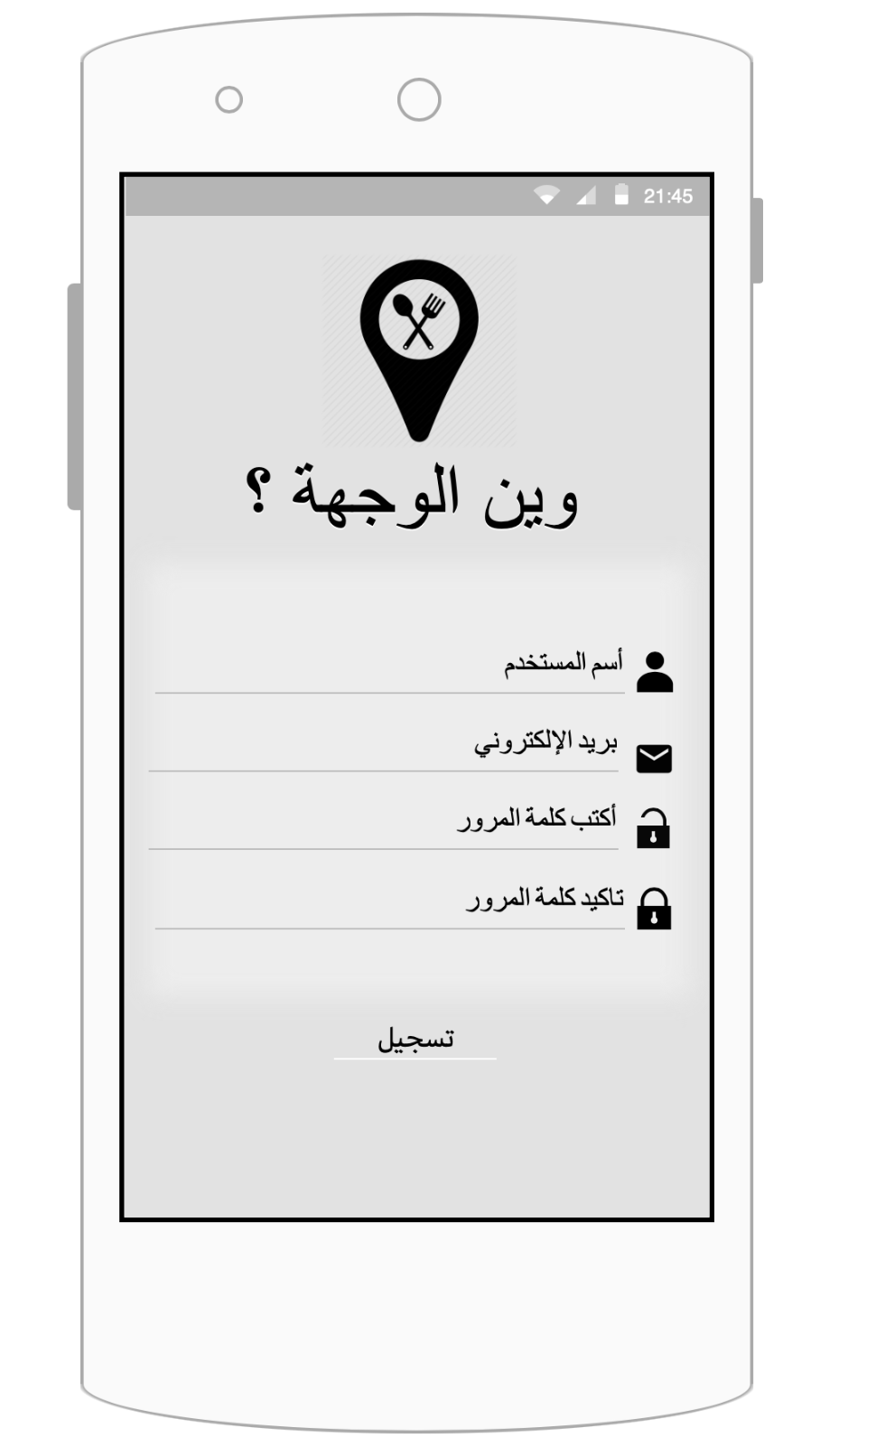

5

4

3

2

1

Figure 5.3: Register page.

|  |  |
| --- | --- |
| Function Number | Function Description |
| 1 | This is an input field for the user’s name |
| 2 | This is an input field for the user’s email. |
| 3 | This is an input field for the user’s password. |
| 4 | This is an input field for the user to repeat his password. |
| 5 | This button checks the input fields, if they are valid, a message will be displayed (as shown in Figure 5.16). then directs the user to the home page.  If some fields are empty or the inputs are not valid, error message will be displayed (as shown in Figures 5.13, 5.14 and 5.17), and the user stays in the same page. |

Table 5.2: Register page.

**3-Restore Password Page**

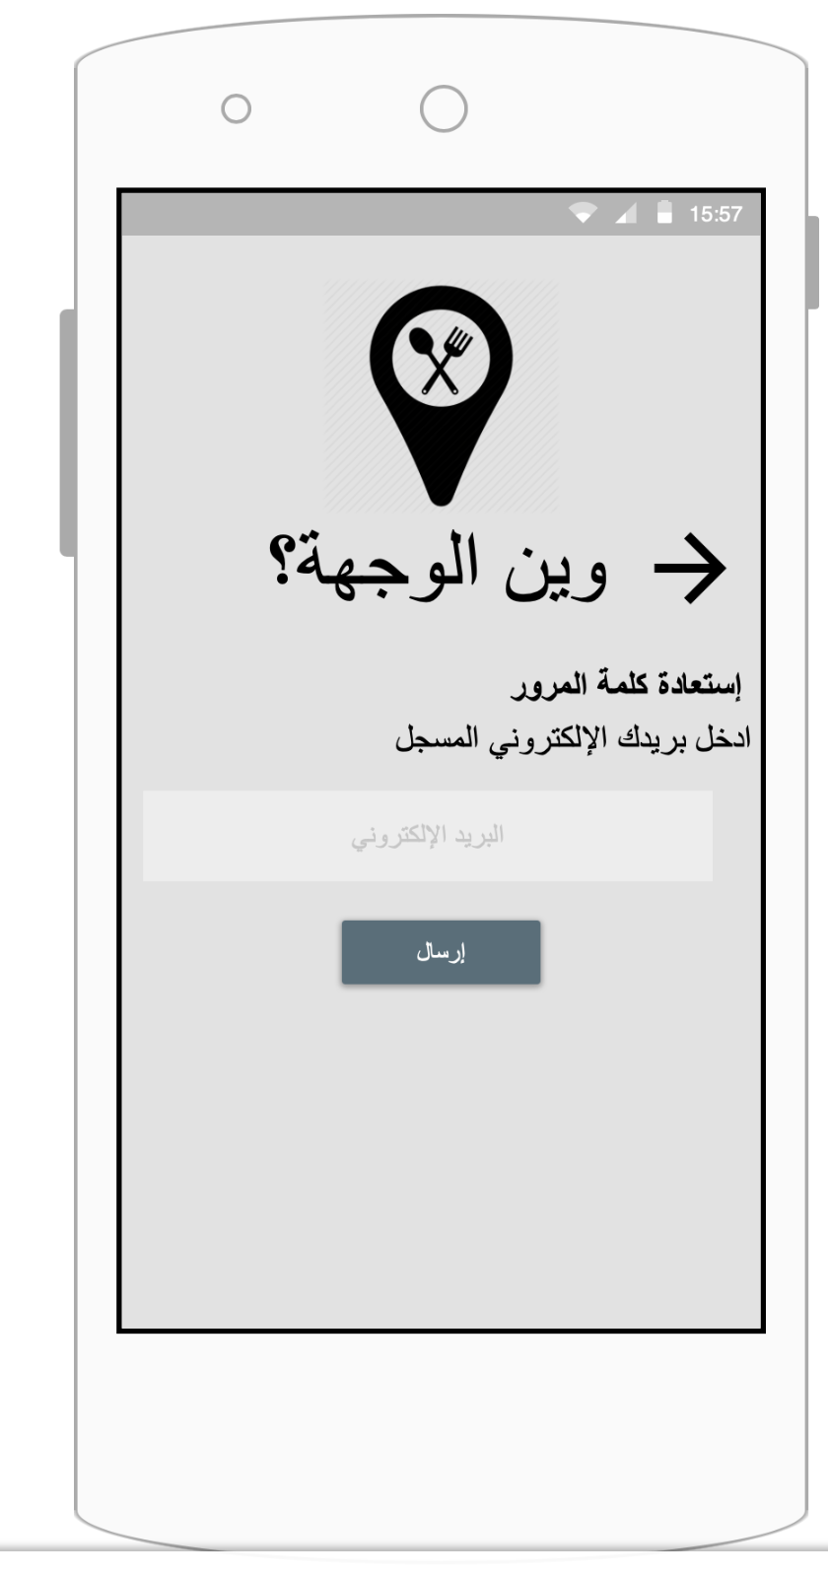

3

2

1

Figure 5.4: Restore Password Page.

|  |  |
| --- | --- |
| Function Number | Function Description |
| 1 | This is an input field for the user’s email. |
| 2 | This button checks the input fields and then directs the user to the login page.  If some fields are empty or the inputs are not valid, error message will be displayed (as shown in Figures 5.12). |
| 3 | This icon directs the user to the previous page. |

Table 5.3: Restore Password page.

**4-Home Page**

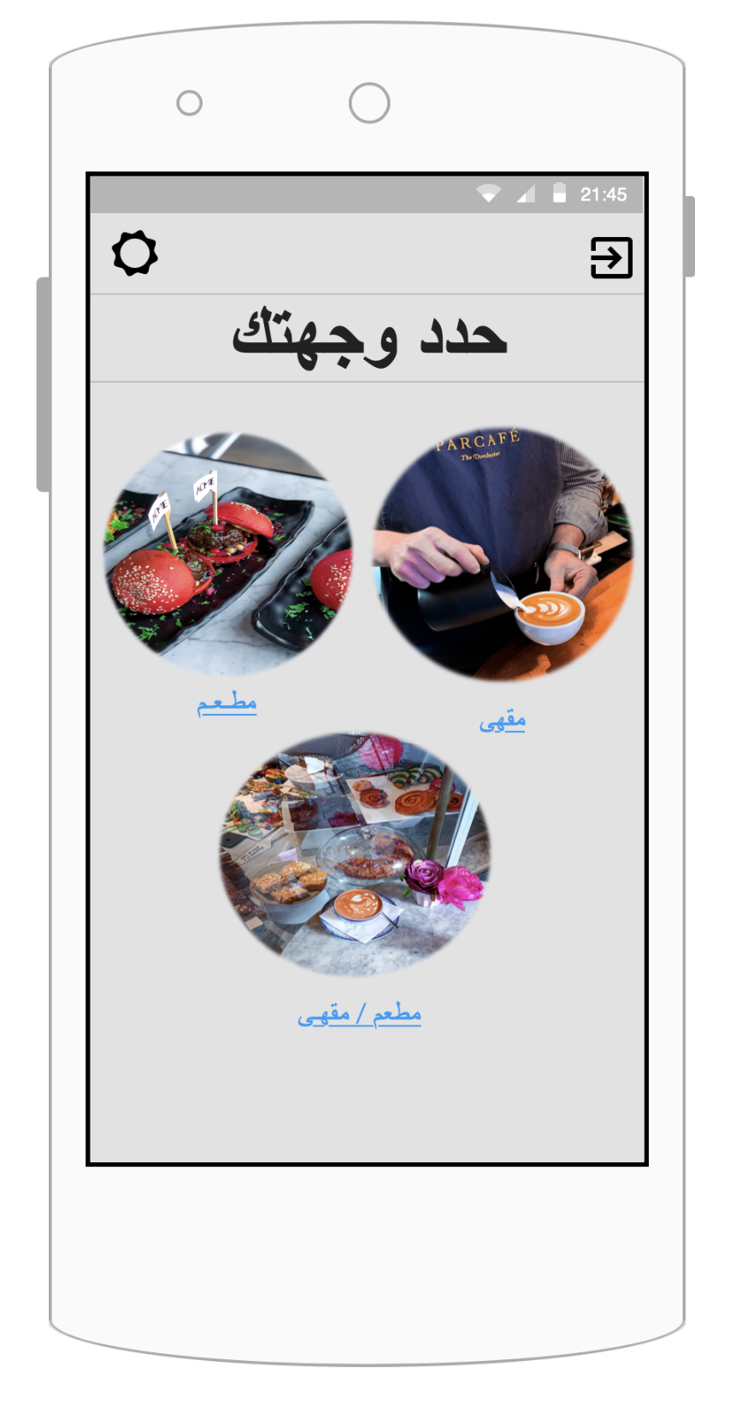

4

5

3

2

1

Figure 5.5: Home Page.

|  |  |
| --- | --- |
| Function Number | Function Description |
| 1 | This is a button for the category: restaurants. |
| 2 | This is a button for the category: café. |
| 3 | This is a button for both the categories: restaurants and café |
| 4 | This icon directs the user to the profile and setting page. |
| 5 | This icon directs the user to the log out of the application. |

Table 5.4: Home page.

**5-The nearby restaurants/café page.**

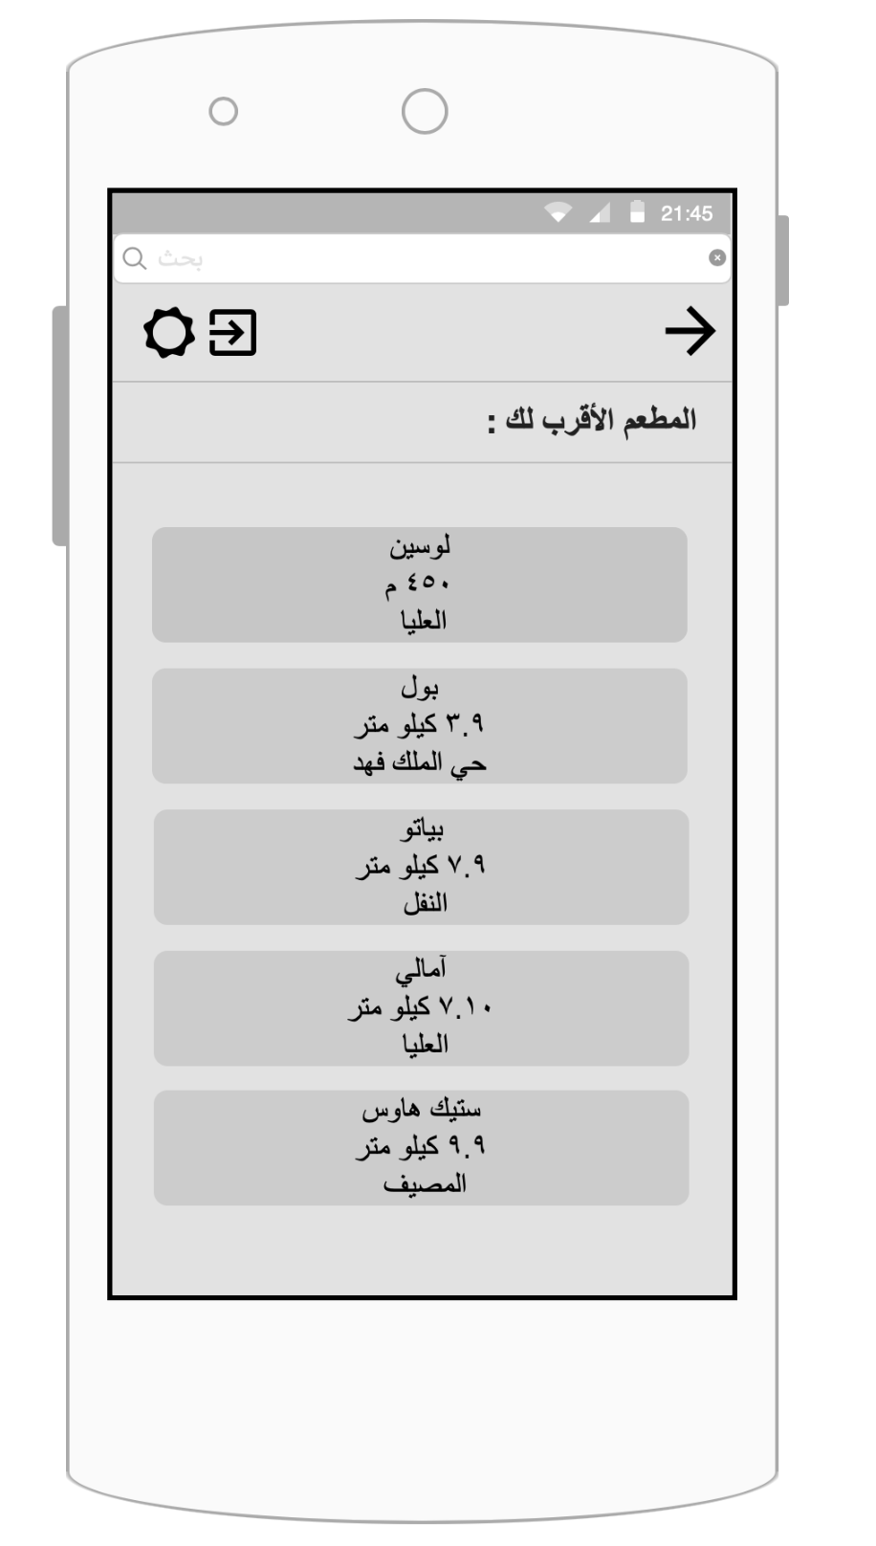

1

4

3

2

5

Figure 5.6: The nearby restaurants/café page.

|  |  |
| --- | --- |
| Function Number | Function Description |
| 1 | This label directs the user to the search by name for restaurants or café. |
| 2 | This icon directs the user to the previous page. |
| 3 | This icon directs the user to the log out of the application. |
| 4 | This icon directs the user to the profile and setting page. |
| 5 | This is a button for a specific restaurant in the search result to display the restaurant page. |

Table 5.5: The nearby restaurants and café page.

**6-The information of restaurants/café page.**

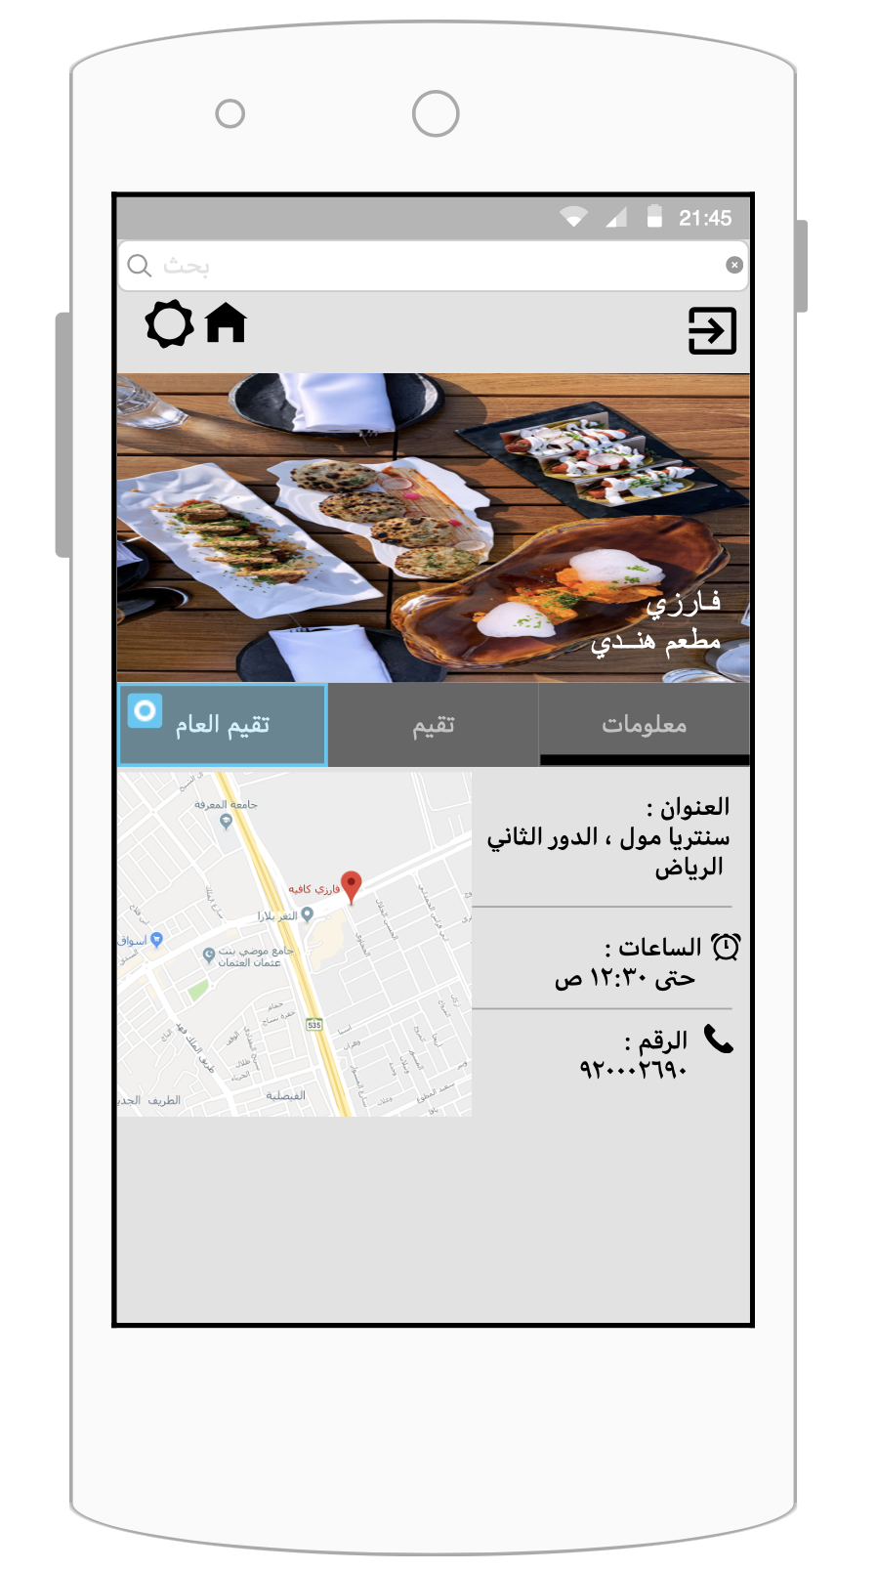

5

4

2

3

1

Figure 5.7: The information of restaurants/café page.

|  |  |
| --- | --- |
| Function Number | Function Description |
| 1 | This label directs the user to the search by name such as the name of restaurants or café. |
| 2 | This icon directs the user to the home page. |
| 3 | This icon directs the user to the profile and setting page. |
| 4 | This icon directs the user to the log out of the application. |
| 5 | This is a button for general restaurants or café information. |

Table 5.6: The information of restaurants or café page.

**7-The reviews of restaurants/café page.**

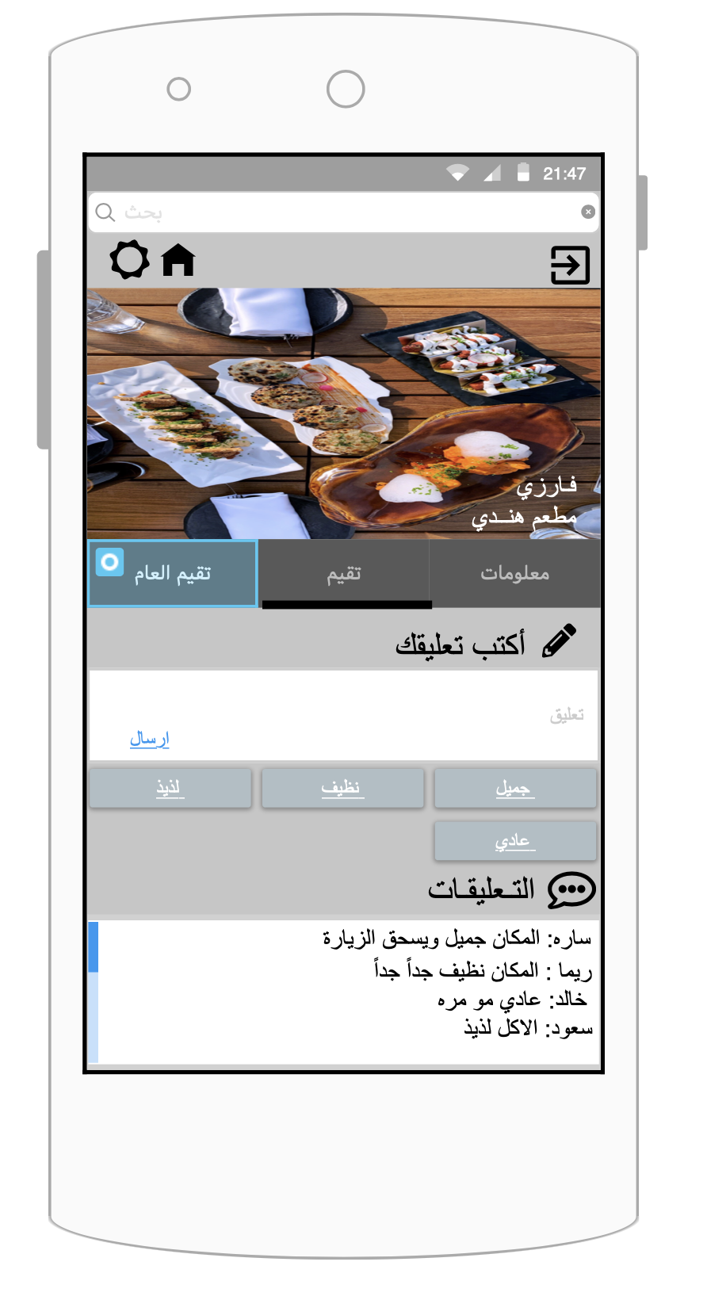

1

4

3

2

5

6

7

8

9

Figure 5.8: The reviews of restaurants/café page.

|  |  |
| --- | --- |
| Function Number | Function Description |
| 1 | This label directs the user to the search by name such as the name of restaurants or café. |
| 2 | This icon directs the user to the home page. |
| 3 | This icon directs the user to the Edit profile and setting. |
| 4 | This icon directs the user to the log out of the application. |
| 5 | This is a button for the restaurant or café reviews. |
| 6 | This label directs the user to the write comments. |
| 7 | This button to send the comments.  But if the user is not logged in the application an error message will be displayed (as shown in Figures 5.11). |
| 8 | This is a button for the keyword filters all (positive and negative words). |
| 9 | This label shows all the comments of users who registers in the application. |

Table 5.7: The reviews of restaurants or café page.

**8-The review summary of restaurants/café page.**

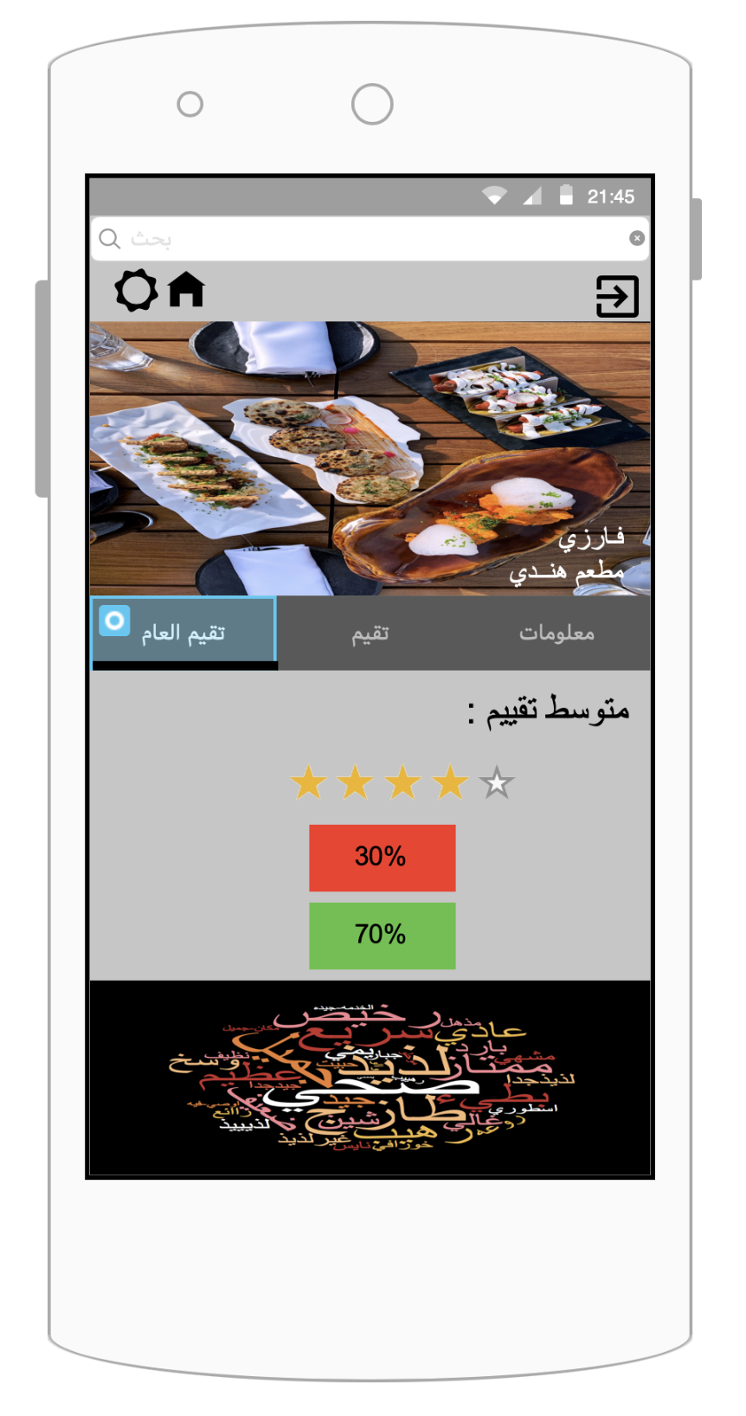

9

8

7

6

5

4

3

2

1

Figure 5.9: The review summary of restaurants/café page.

|  |  |
| --- | --- |
| Function Number | Function Description |
| 1 | This label directs the user to the search by name such as the name of restaurants or café. |
| 2 | This icon directs the user to the home page. |
| 3 | This icon directs the user to the profile and setting page. |
| 4 | This icon directs the user to the log out of the application. |
| 5 | This is a button for specific restaurants or café review summary. |
| 6 | The average rating for restaurant or café. |
| 7 | The percentage of negative keywords |
| 8 | The percentage of positive keywords |
| 9 | The word cloud of all positive and negative words. |

Table 5.8: The reviews of restaurants or café page.

**9-Profile Page (Edit profile/ Settings)**

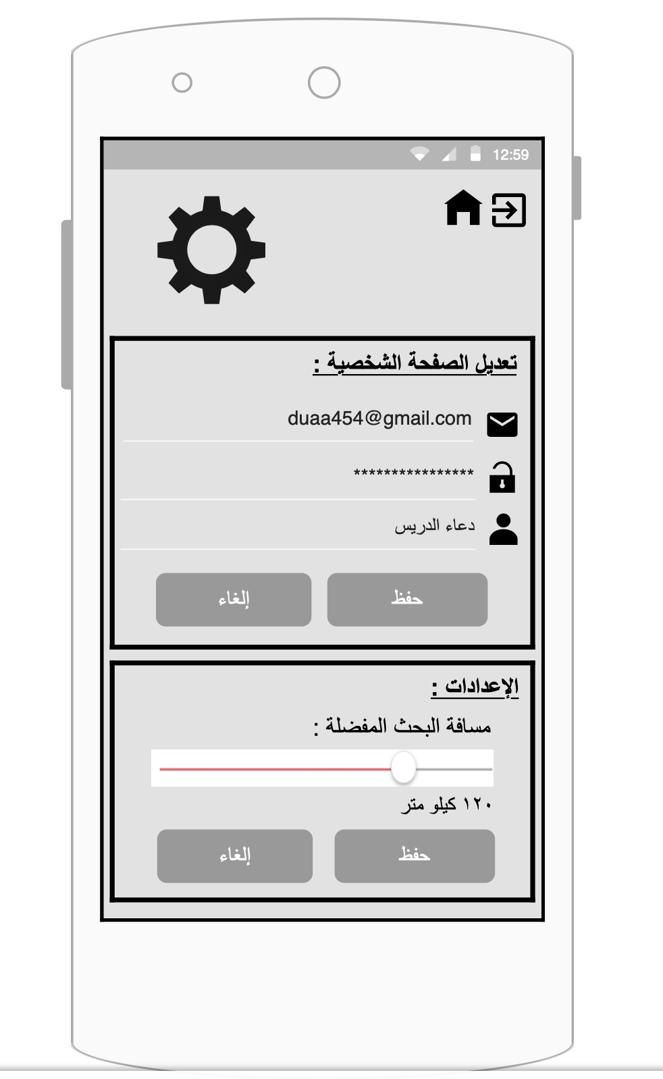

2

1

3

5

4

6

7

8

9

Figure 5.10: Profile Page (Edit profile/ Settings).

|  |  |
| --- | --- |
| Function Number | Function Description |
| 1 | This icon directs the user to the home page. |
| 2 | This icon directs the user to the log out of the application. |
| 3 | This area consists of input fields filled with user profile information. |
| 4 | This is a button to save the edited profile information. |
| 5 | This is a button to cancel the editing the profile. |
| 6 | This area consists of settings for the user. |
| 7 | This a button to select a prefered search distance. |
| 8 | This is a button to save the edited settings information. |
| 9 | This is a button to cancel editing the settings. |

Table 5.9: Profile page (Edit profile/ Settings)

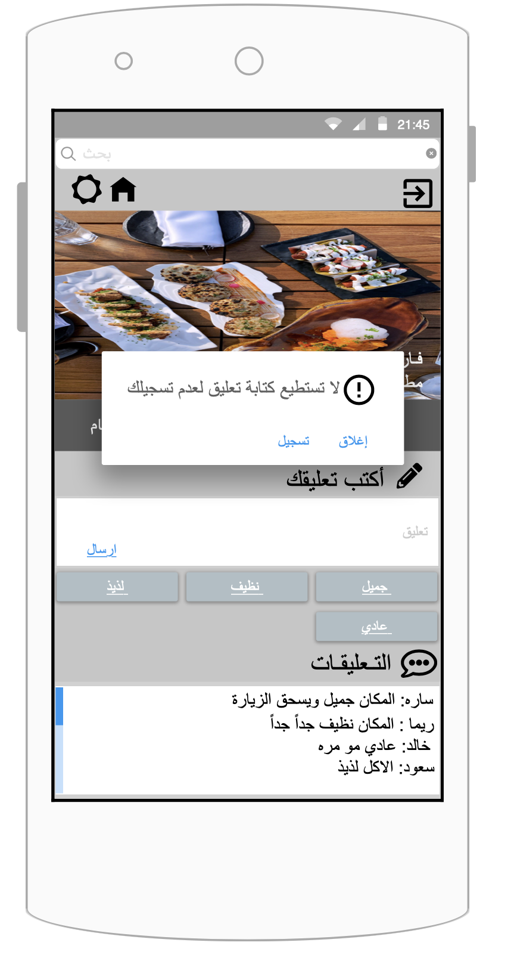**10-Messages**

Figure5.11: Error message if the User doesn’t have an account in the application.

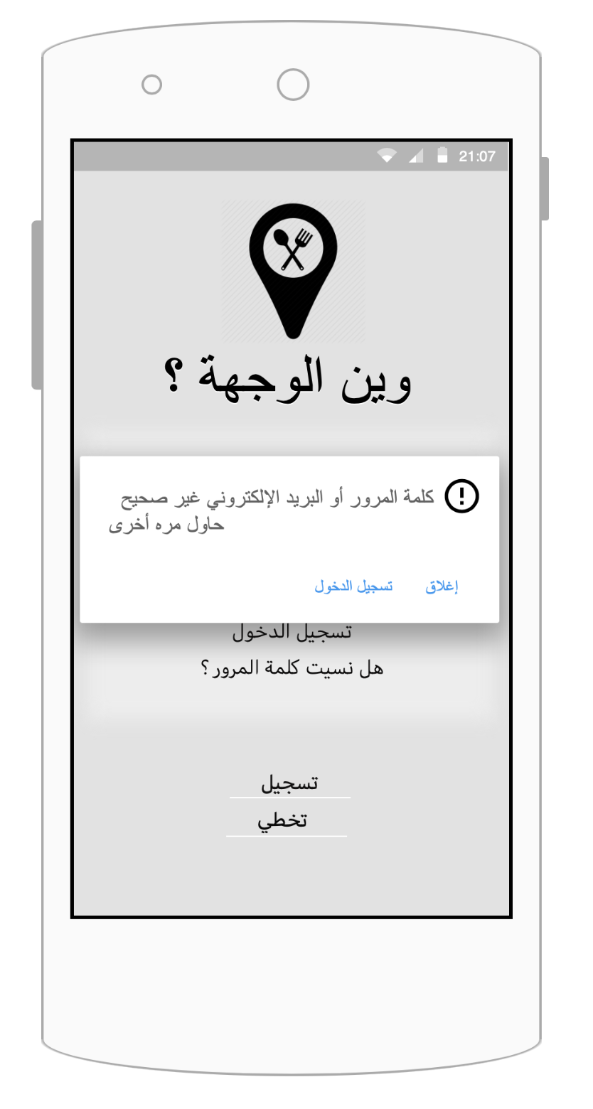

Figure 5.12: Email and password error message.

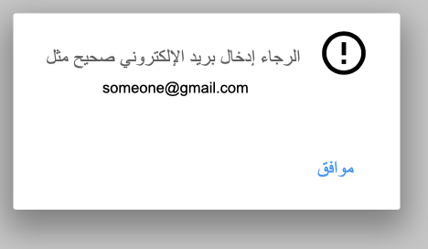

Figure 5.13: Email format error message.

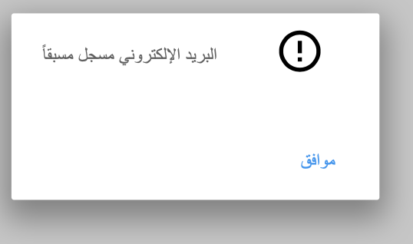

Figure 5.14: Email format error message.

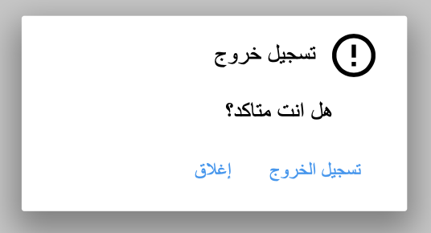

Figure 5.15: Logout message

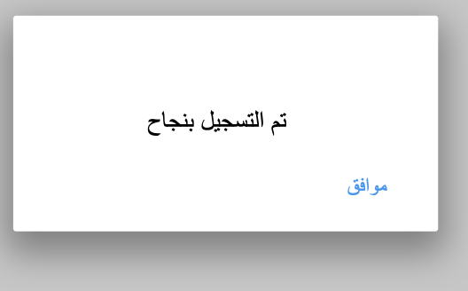

Figure 5.16: Successfully registered message.

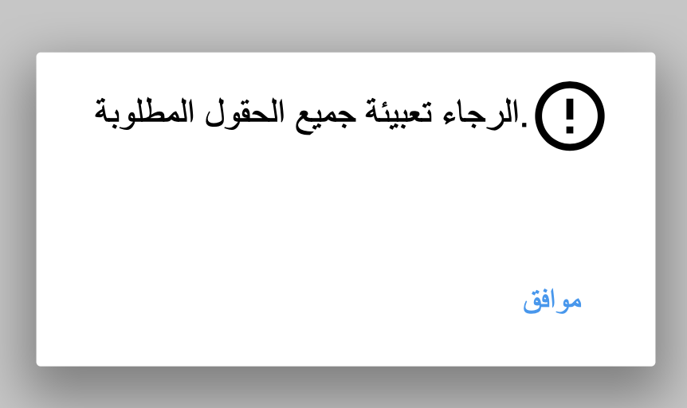

Figure 5.17: Successfully registered message.

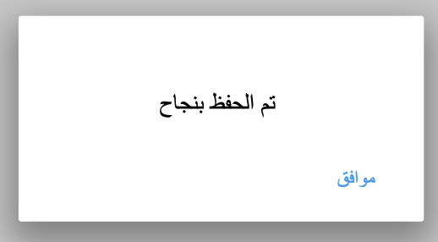

Figure 5.18: Save successfully message.